**LAB 1**

**Introduction**

Tasm + Note pad/ Notepad +

Save file with .asm in C drive tasm 1.4 folder

**How to Run the program?**

You need to follow three steps

1. Tasm filename.asm ; helps you to find error in the program
2. Tlink filename .obj ; Create object file for machine
3. Filename or file name.exe ; create executable file or show result on screen

1. **Create program to print a character.**

Segments

.model small

.stack 100h

.data

.code

Start:

Label used for starting the program code

Code for print a character

Mov ah, 2h

Mov dl,’N’

Int 21h

Code for Exit from the code

Mov ah, 4ch

Int 21h

End start

End the Label

**Task**

**Create a program which print 0 on screen with the help of ASCII code.**

**SOURCE CODE:**

.model small

.stack 100h

.data

.code

start:

mov ah,02

mov dl,48

int 21h

mov ah,4ch

int 21h

end start

**OUTPUT:**

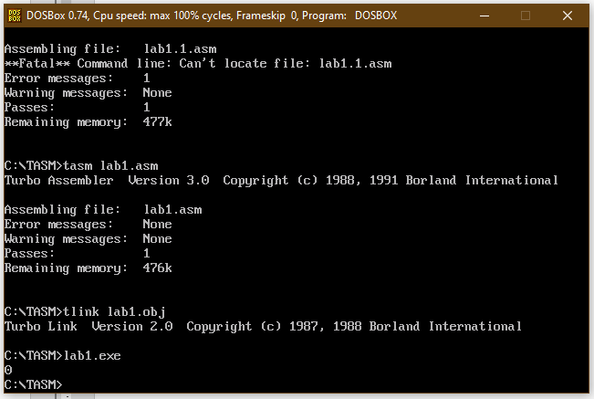

**Create a program which print A character with the help of ASCII code.**

**SOURCE CODE:**

.model small

.stack 100h

.data

.code

start:

mov ah,02

mov dl,'A'

int 21h

mov ah,4ch

int 21h

end start

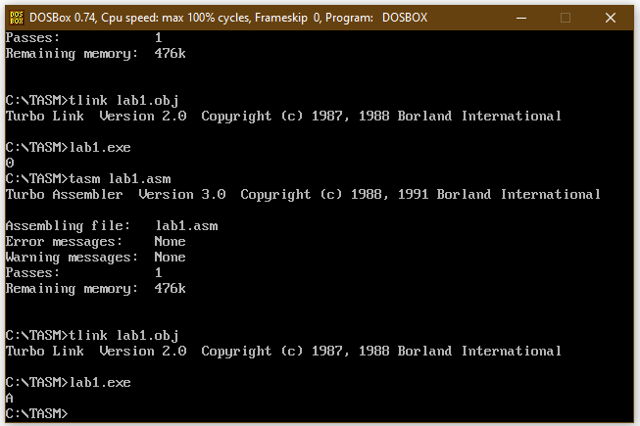**OUTPUT:**

**Create a program which print your name with the help of function 02.**

**SOURCE CODE:**

.model small

.stack 100h

.data

.code

start:

mov ah,02

mov dl,'R'

int 21h

mov ah,02

mov dl,'A'

int 21h

mov ah,02

mov dl,'F'

int 21h

mov ah,02

mov dl,'E'

int 21h

mov ah,02

mov dl,'H'

int 21h

mov ah,4ch

int 21h

end start

**OUTPUT:**

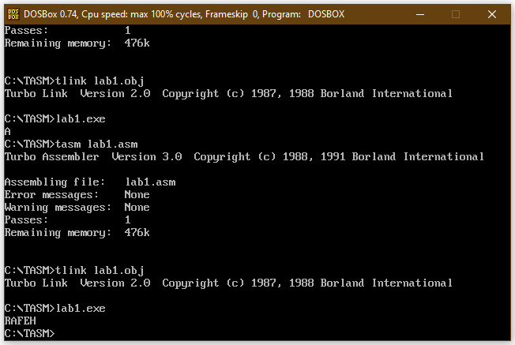

**Write all errors which you know about in today class and write how you correct them.**

**ERROR 1:**

(,) extra.

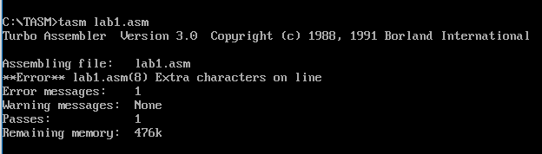

**SOLUTION:**

Remove (,) from line no 8.

**ERROR 2:**

File name is not correct.

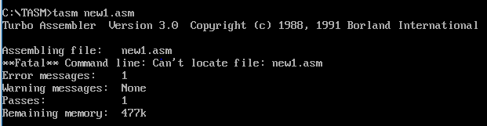

**SOLUTION:**

Rewrite the exact file name.